The intent of this product is to be a resource, not a replacement for institutional protocols. Standard 1 of AmSECT’s Standards and Guidelines for Perfusion Practice.¹ These Standards and Guidelines may also be superseded by the judgment of the healthcare professional taking into account the facts and circumstances of the individual case.

SUBJECT/TITLE: Pulmonary Artery Flow Study for Unifocalizations
PURPOSE:
Purpose/Definition
This technique will be performed on select patients with tetralogy of Fallot (TOF), pulmonary atresia, or aortopulmonary collaterals (MAPCA's) who are undergoing unifocalization, to guide the surgical management of the ventricular septal defect (VSD). This protocol outlines the cardiovascular perfusionist’s role and responsibility for the conduct of an intraoperative pulmonary flow study to determine the appropriateness of ventricular septal defect closure in the presence of pulmonary atresia and major aortopulmonary collaterals. This procedure is for use with roller pump cardiopulmonary bypass (CPB) circuits only.
TARGET POPULATION:
Patients with TOF, pulmonary atresia, and aortopulmonary collaterals (MAPCA's) undergoing a unifocalization procedure.
DEFINITIONS:
- Tetralogy of Fallot (TOF): A congenital heart condition including a VSD, overriding aorta, pulmonary stenosis, and RV hypertrophy.
- Major Aortopulmonary Collateral Arteries (MAPCA’s): A congenital heart defect with persistent tortuous fetal arteries that arise from the descending aorta and supply blood to pulmonary arteries in the lungs usually at the posterior aspect of hilum.
- Ventricular Septal Defect (VSD): A congenital heart defect in which there is a defect in the ventricular septum.
- Pulmonary Atresia: A congenital heart defect resulting in an absent pulmonary valve.
- Unifocalization: A cardiac surgery performed soon after birth to reroute MAPCAs from the aorta to the pulmonary artery and restore the normal circulation from the lungs to the heart.
IMPORTANT LIMITATIONS OF THIS DOCUMENT:
- In emergency situations, immediate life support measures of whatever appropriate nature come first with attention turning to measures described in this protocol/process as soon as possible and practical.
- The judgement of the healthcare professional, taking into account all of the patient’s circumstances, should always take precedence over these protocols. This protocol/process encourages high quality patient care but observing it cannot guarantee any specific patient outcome.
- AmSECT reserves the right, but not the duty, to update this protocol from time to time. Review period: Review as changes occur or per institutional protocol.
- Original hard copies and computer copies of this protocol are stored under the supervision of the Chief Perfusionist, Department of Cardiovascular Perfusion.
- Documents relating to patient care standards are developed according to the accepted hospital standards.

POLICY:
This is a guideline.

CIRCUIT DESIGN CONSIDERATIONS:
Equipment and Circuitry
- Standard CPB set up utilizing roller pump arterial head, appropriately sized to the patient
- An additional roller head
- Sterile tubing the same size as the arterial line for the sterile field to hand down
- Consider a larger or additional LV vent(s) due to pulmonary flow returning to the pump through this vent during the PA flow study
- Consider adding additional suckers to compensate for the MAPCAs and any additional blood loss
- Additional PA cannula, same size as the arterial cannula.
- Consider monitoring pressure in the additional PA cannula/line
- PA pressure must be monitored during flow study
- This study is based on volume, so while vacuum assisted venous drainage (VAVD) can be used, adequate volume is critical
- PA and LA recorded at a steady flow rate

Circuit Modifications
- Insert a wye connector into the pump boot post venous reservoir and pre arterial pump
- One leg of the wye connects to the arterial pump boot and the other leg connects to the PA flow study pump boot (appropriately sized to accommodate a 3.0 CI. Insert a straight luer-ed connector post PA flow study pump to attach a pressure line to monitor the flow study circuit pressure
- Prime the circuit as normal and make sure to check the occlusion of the PA flow study pump. The PA flow study pump can be temporarily connected to the cardiotomy to prime the system and check occlusions. Consider linking the PA flow study pump to the arterial pump, stopping both pumps for pressure, level, or bubble alarms
- Consider adjusting transducer pressure limits to accommodate the size of patient and total blood flow required for the 2.5-3.0 CI blood flow

PROCEDURE:

1. Prior to starting flow-study:
- Upon pushing up to the operating table, connect the sterile tubing to be used for the PA flow study to the connector on the outflow side of the flow study pump. Prime this line up to the field
- Initiate bypass and conduct the case according to institutional protocol. Be prepared for the use of pH stat blood gas management for patients with major aortopulmonary collaterals. Have extra volume available (blood products may be necessary) for the initiation of the PA flow study
- Additional cooling may be appropriate
2. Conduct of the PA Flow Study:
- Prior to the start of the study, ensure adequate volume in the reservoir to handle the extra flow generated by the PA flow study. The surgeon will instruct initiation of the study and specify a target cardiac index for the PA flow study pump
- At the request of the surgeon, increase vent speed to match PA flow study pump
- Increase PA flow study pump at the direction of the surgeon
- Record pulmonary flow and pulmonary pressure for each stage of the PA flow study
- At the request of the surgeon, turn off the PA flow study pump
CLINICAL ASSESSMENT/SCREENING:
- Screening
The surgeon will assess the PA pressure through a pressure line that was given to anesthesia. If the pressure is less than 25 mmHg, the surgeon will ask you to increase systemic flow to a 2.0 l/min/m2 CI and will go up to a 2.5 or 3.0 CI as long as the pressure stays below 25 mmHg. Once pressure gets above 25 mmHg the surgeon will stop the study. If the pressure was greater than 25 mmHg they will most likely not close the VSD, or he will close it and fenestrate it. Target systemic flow 2.5 L/min/m²- 3.0 l/min/m2.
If PA pressure <15mmHg at ~1.25 L/min/m2, then proceed with a bidirectional Glenn procedure.
- Contraindications:
Inability to adequately vent the LA, which results in myocardial distension and inappropriately high measured PA pressure.
RELATED DOCUMENTS:
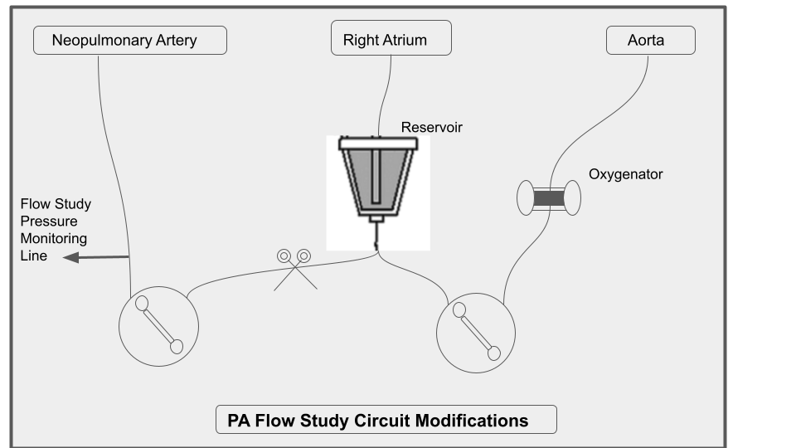
REFERENCES:
1) Carotti A, Albanese S, and DiDonato R. Unifocalization and Repair of Pulmonary Atresia with Ventricular Septal Defect and Major Aortopulmonary Collateral Arteries. Acta Paediatrica. 2006; 95: 22-26.
2) Haga-Greco T and Niimi K. Construction of a Pulmonary Artery Pump for Unifocalization and Repair of Pulmonary Atresia with Ventricular Septal Defect and Major Aortopulmonary Collaterals." Perfusion. 2005; 20: 109-113.
3) Honjo O, Al-Radi O, MacDonald C, et al. The Functional Intraoperative Pulmonary Blood Flow Study Is a More Sensitive Predictor than Preoperative Anatomy for Right Ventricular Pressure and Physiology Tolerance of Ventricular Septal Defect Closure After Complete Unifocalization in Patients with Pulmonary Atresia, Ventricular Septal Defect, and Major Aortopulmonary Collaterals. Circulation. 2009; 120: S46-S52.
4) Mohan R, Petrossian E, McElhinney D, et al. One-stage Complete Unifocalization in Infants: When Should the Ventricular Septal Defect Be Closed? J Thorac Cardiovasc Surg. 1997; 113: 858-868.
5) Carotti A, Di Donato R, Squitieri C, et al. Total repair of pulmonary atresia with ventricular septal defect and major aortopulmonary collaterals: an integrated approach. J Thorac Cardiovasc Surg. 1998; 116(6): 914-23.
6) Malhotra SP, Hanley FL. Surgical management of pulmonary atresia with ventricular septal defect and major aortopulmonary collaterals: a protocol-based approach. Semin Thorac Cardiovasc Surg Pediatr Card Surg Annu. 2009:145-51.
7) Grosse-Wortmann L, Yoo SJ, van Arsdell G, et al. Preoperative total pulmonary blood flow predicts right ventricular pressure in patients early after complete repair of tetralogy of Fallot and pulmonary atresia with major aortopulmonary collateral arteries. J Thorac Cardiovasc Surg. 2013; 146(5): 1185-90.
8) Trezzi M, Bandisode V, Kavarana M, et al. Intraoperative pulmonary flow study for decision making in the comprehensive stage II hybrid procedure. J Thorac Cardiovasc Surg. 2014; 148(2): 743-5.
APPROVED BY: (signature of required team members)
Source: | (originating department/committee)
Effective Date: | (can use ‘created date’ for this)
Version Number: | (should match # of revisions, use 1.0 if new document)
Date Revised: | MM/YYYY; all dates any content changes were made
Date Reviewed:
Signatures:
 | Date:
<Insert Name, Title>
 | Date:
<Insert Name, Title>
 | Date:
<Insert Name, Chief Medical Officer >
 | Date:
<Insert Name, Chief Nursing Executive>

